# Instructions for using ARM Template to deploy Azure PaaS resources

1. Install the PowerShell command line tool for Azure, if it is not already installed on the workstation:

<https://azure.microsoft.com/en-us/downloads/>

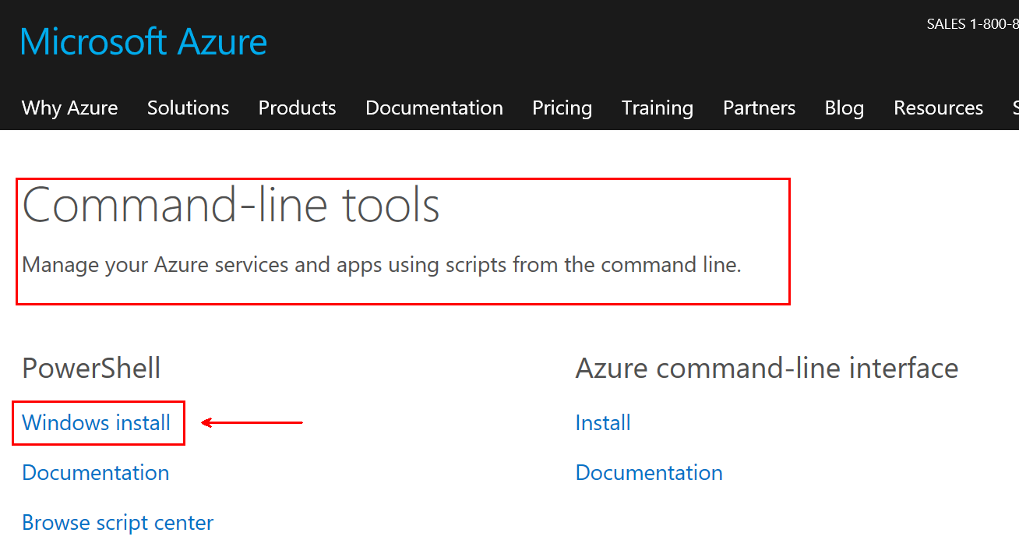

1. Extract the **HEDWPaaSTemplate.zip** file to C:\TEMP\HEDWPaaSTemplate or another location:

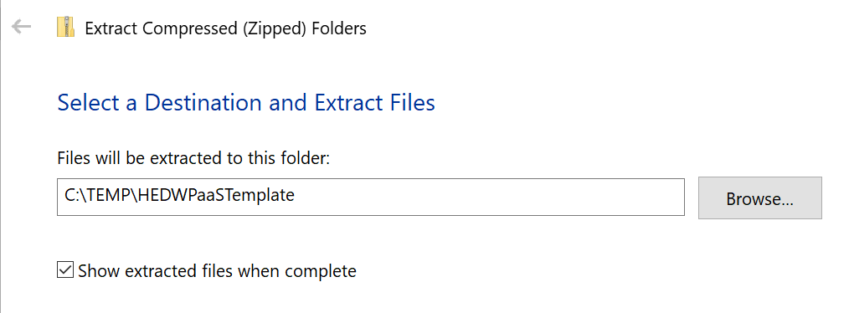

1. There should be 2 files contained in the zip file:

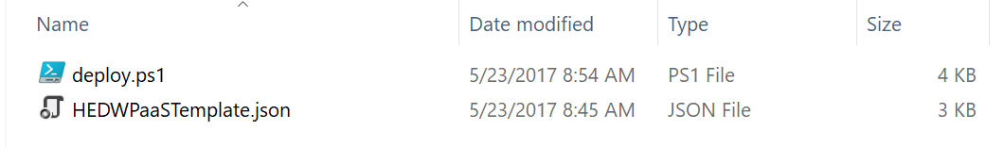

1. Open a command window and change directory to the location that you extracted the zip file to in step 1:

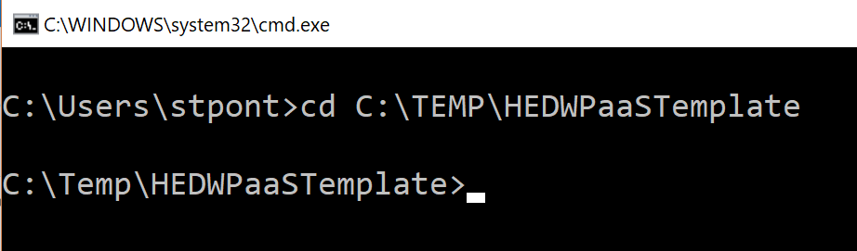

1. Type in the following command to run the **deploy.ps1** PowerShell script which will deploy the resources defined in the **HEDWPaaSTemplate.json** ARM template:

powershell -f .\deploy.ps1

1. A prompt for entering an Azure Subscription ID should appear. Enter the Azure Subscription ID that will be used for provisioning PaaS resources needed to complete the hackathon:

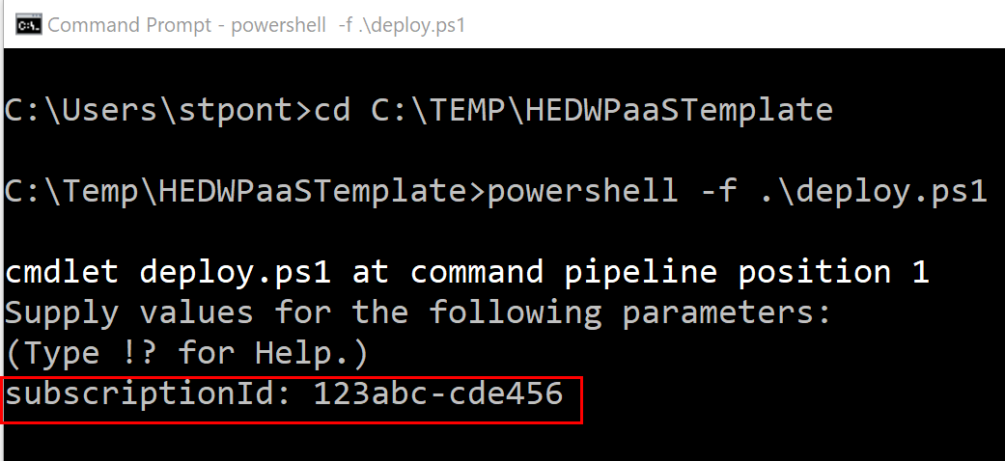

1. The next prompt will be for a name for the resource group that will contain all of the PaaS servers provisioned for the hackathon. The name will be used to provision a storage account, a SQL database server and an analysis services server. The script will use the name and add on “suffixes” for each object provisioned.

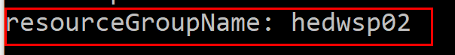

In the example, **hedwsp02** is used and will result in the following Azure resources being provisioned:

|  |  |
| --- | --- |
| Name | Resource Type |
| hedwsp02 | Resource Group |
| hedwsp02as | Analysis Services Server |
| hedwsp02sql | SQL DB Server |
| hedwsp02storage | Storage Account |

1. The next prompt will be for the resource group location. A list of Azure Region names can be found here:

<https://azure.microsoft.com/en-us/regions/>

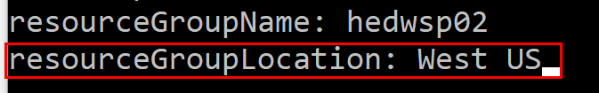

1. The next prompt will ask for a credential needed to sign into the Azure tenant and provision the PaaS servers:

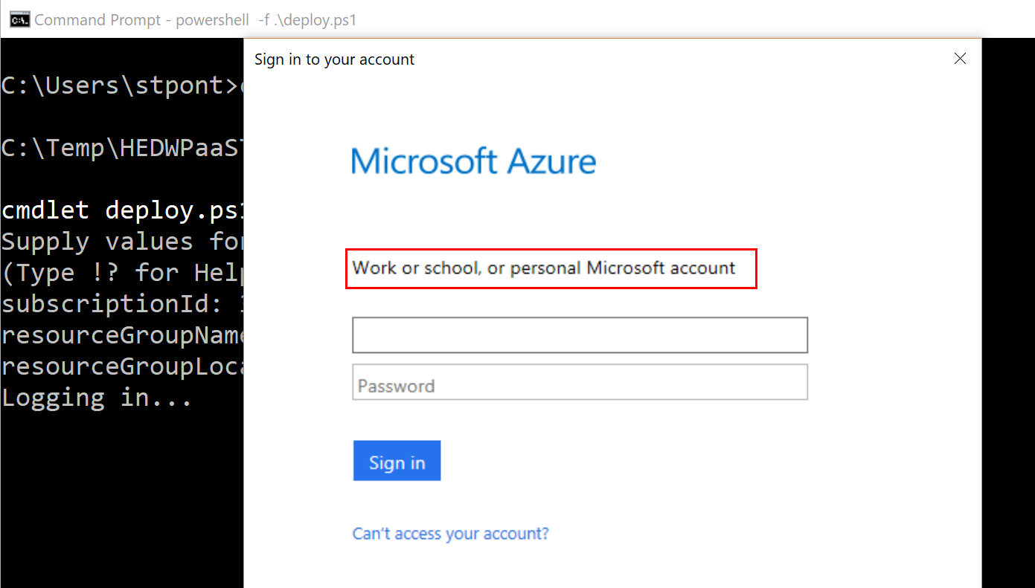

1. After successfully signing into the account, information about the environment and account used will scroll through the command window. The next prompt will be for the name of the **SQL Server Administrator**. Enter a name that will be used for the SQL Server Administrator:

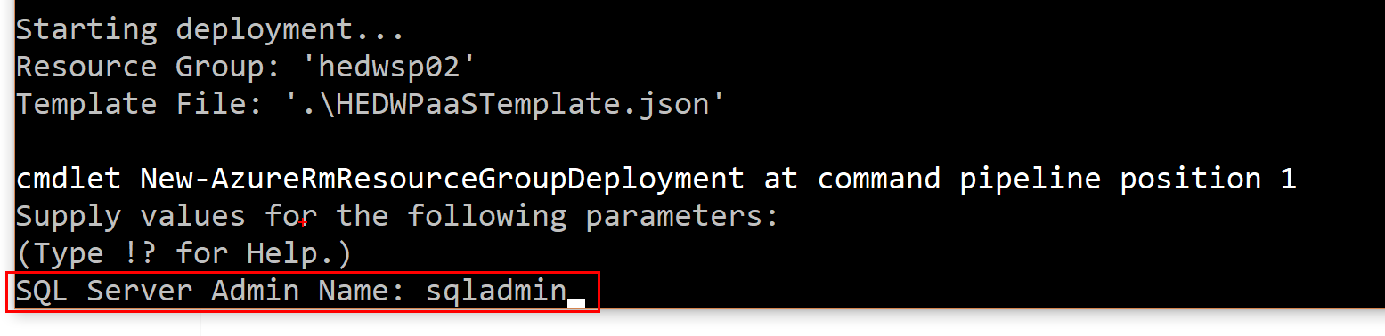

1. The next prompt will be for the password for the **SQL Server Administrator**. Enter a password that meets the following requirements: <https://docs.microsoft.com/en-us/sql/relational-databases/security/password-policy>

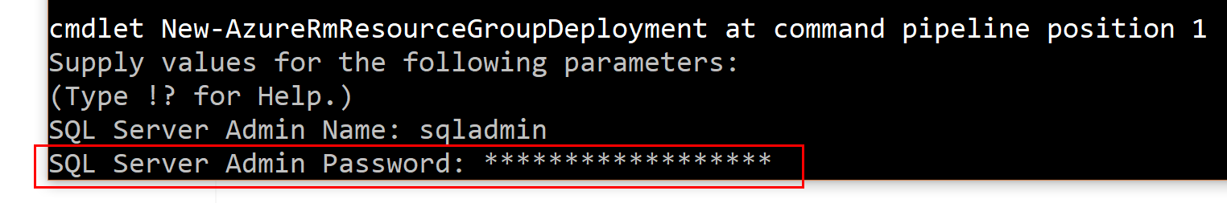

1. Once the password has been entered, the cursor may just blink at the bottom of the command window while the servers are being provisioned:

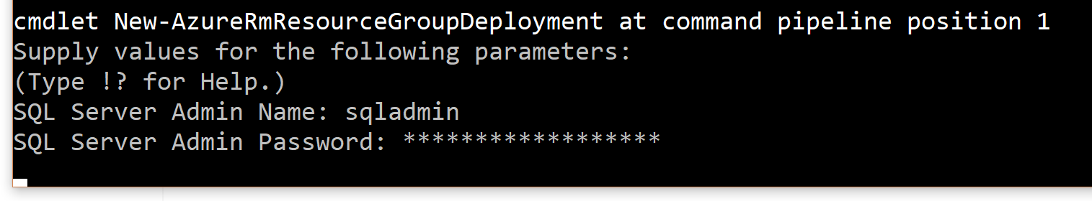

1. Eventually the provisioning will complete, additional output will scroll through the command window and the PowerShell script will complete and exit:

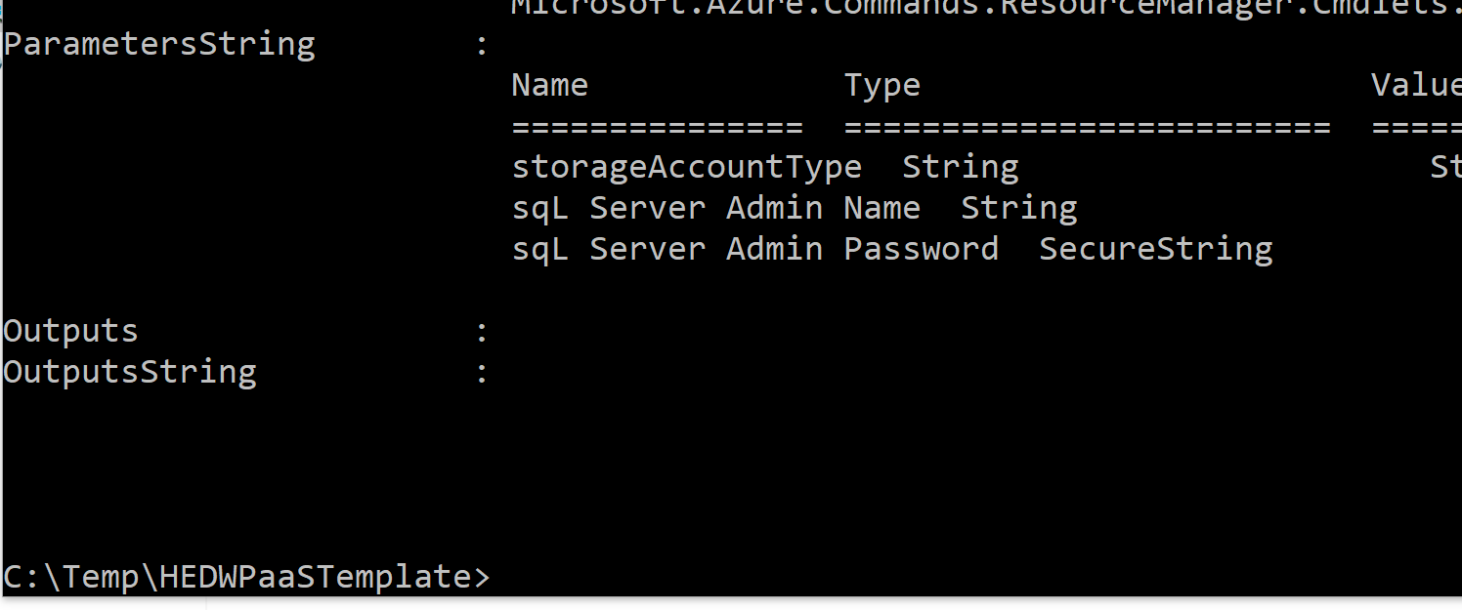

1. Log into the azure portal. The new **Resource Group** should now be provisioned and contain the SQL Server and Analysis Services servers that were created:

|  |  |
| --- | --- |
|  |  |

1. Select the Analysis Services server to open the overview blade. **IMPORTANT** - If the Analysis Services server is not going to be actively utilized, make sure to select **Pause** to pause the compute resources allocated to the server and minimize charges:

|  |  |
| --- | --- |
|  |  |